Hipokratis

Global Chain

October 8, 2013

Team Members:

- Ahmet KORKMAZ, 1648070, ahmett.korkmaz@gmail.com
- Barış KENİŞ, 1746155, bariskenis@gmail.com
- Erkan ONAT, 1679133, erkan.onat90@gmail.com
- Oğuz ÖRCÜN, 1679455, e167945@metu.edu.tr

- Problem Definition and Background Information

Radiography is the use of X-rays to view a non-uniformly composed material such as the human body. ^{[1]} The resulting images of this technique are generally used to find anomalies in the bone structure of humans. These images should be interpreted by a radiologist.

In our country, the radiologists cannot answer the demand because of their workload. Since the radiologists are so busy, sending the patient to them and asking for a roentgen can be a long process. Because of that situation, in some cases, doctors who are not radiologist may have to interpret the radiographic image by themselves. Due to all these reasons, some anomalies in the radiographic images are missed by the doctors.

Human hand contains a lot of little bones and joints. Because of this, it is much easier to make mistakes while interpreting the hand roentgens. For this reason, this problem is especially important in hand roentgens.

According to the professor Prof. Dr. Okan Akhan who is the president of the Turkish Radiology Association, there 3400 radiologists in Turkey. ^{[2]} This problem affects most of these radiologists and also their patients.

There are no solutions or products for this problem in Turkey, which are currently in use.

- Significance of the Problem and Motivation

There are 4 main reasons that make this problem challenging:
- It is hard to process images in such small details
- There are many different anomalies to look for
- Every human hand is different; therefore it is hard to understand whether an abnormal point in roentgen is problematic or a part of natural structure of hand.
- The solution requires combining the disciplines of computer science and medicine field
We decided on this project because we believe that this project will be more beneficial and useful for people compared to other publicly proposed project ideas.

If we can manage to solve this problem, radiologists will be able to process the roentgens more quickly and their workload will be reduced considerably. Also, doctors who are not radiologists will be able to interpret radiographic images more accurately and the mistakes will be reduced.

We are planning to turn our project into a commercial product. We will apply for software competitions and try to gain capital support.

- Draft Project Plan

The project has two distinct parts.

First part is about processing the radiographic image and finding anomalies in that image. The image will be converted to a grayscale image and then with the help of the edge detection algorithm, the image will be split into parts. The image analysis will be conducted by searching for certain predefined injuries and also by comparing the image with a reference.

Second part is about creating a database for the project. The radiographic images that are processed using the image analysis will be stored anonymously in an online database with their diagnosis. MongoDB will be used to store images and Amazon Web Services will be used to host that database.

The end product will be a web application. That web application will allow uploading radiographic images and downloading their processed versions. The processed image will be the uploaded radiographic image which has the anomalies in it marked and commented. Furthermore, in the application, there will be an option to consult similar radiographic images.

The user will be able to reach the application online. The user will upload the radiographic image that needs to be interpreted and will download the processed version of the image. If needed, the user will be able to consult the stored images in the database.

The major tasks of the project will be divided as follows:
- Image processing part : Barış Keniş, Oğuz Örcün
- Database and web service part : Ahmet Korkmaz , Erkan Onat

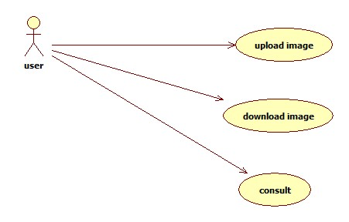
Use Case Diagram
Use case scenarios are depicted in the above UML diagram.

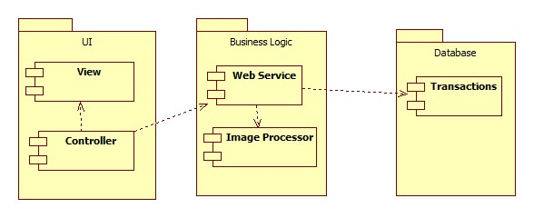
Component Diagram
In the UI component, Javascript will be used as main programming language. Javascript framework AngularJS will be used. Ahmet Korkmaz and Erkan Onat will work on these modules.

In business logic side, web service component will be implemented using PHP. It will be like an API Server. The input format for the web service will be json. For the image processor component, Java will be used. Barış Keniş and Oğuz Örcün will be working on this part.

In database side, MongoDB will be used since it is highly scalable and flexible.

Deployment Diagram

- Support

No support.

- References

[1] http://en.wikipedia.org/wiki/Radiography

[2] http://www.medikalplus.com/roportaj/98-radyoloji-hizmetinde-nicelik-deil-nitelik-oenemlidir.html

